import java.io.\*;

import java.util.Scanner;

public class pattern{

public static void main(String args[])

{

Scanner sc=new Scanner(System.in);

int n=sc.nextInt();

for(int i=1;i<=n;i++)

{

for(int j=0;j<1;j++){

if((i+j)%2==0){

System.out.print("0");

}

else{

System.out.print("1");

}

}

System.out.println();

}

}

}

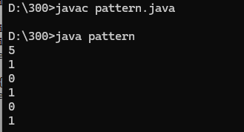

import java.io.\*;

import java.util.Scanner;

public class cse{

public static void main(String args[]){

Scanner sc=new Scanner(System.in);

int n=sc.nextInt();

for(int i=n;i>=1;i--){

for(int j=1;j<=i;j++){

System.out.print(j);

}

System.out.println();

}

}

}

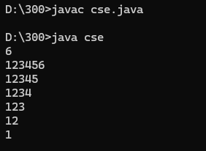

import java.io.\*;

import java.util.Scanner;

public class days{

public static void main(String args[]){

Scanner sc=new Scanner(System.in);

String n=sc.nextLine();

switch(n){

case "Monday":

case "Tuesday":

case "Wednesday":

case "Thursday":

case "Friday":

System.out.println("It's a weekday");

break;

case "Saturday":

case "Sunday":

System.out.println("It's a weekend");

break;

default:

System.out.println("Invalid input");

break;

}

}

}

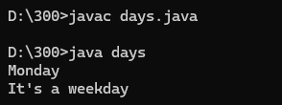

import java.io.\*;

import java.util.Scanner;

public class num{

public static void main(String args[]){

Scanner sc=new Scanner(System.in);

int n=sc.nextInt();

int temp=n;

int sum=0;

while(n>0){

int d=n%10;

int fact=1;

for(int i=1;i<=d;i++){

fact=fact\*i;

}

sum=sum+fact;

n/=10;

}

if(sum==temp){

System.out.println("Strong number");

}

else{

System.out.println("Not Strong number");

}

}

}

